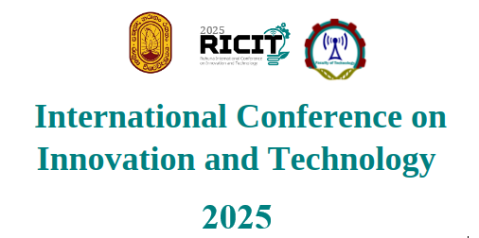

**GUIDELINES FOR ORAL PRESENTATIONS**

1. Oral presentations will be held on 16th December 2025 and will be conducted physically. Each author will be given a total of 10 minutes followed by the Q&A session.
2. Authors should forward their presentations to ricit_conf@fot.ruh.ac.lk by 25th October 2025. However, we expect authors to keep an updated copy available with you, whenever you physically participate in the conference. 3. Presenting authors should be registered for their sessions and be available at their venue at least 10 minutes before the session starts.
3. Presentations should be named as, (RICIT2025_Paper ID).
4. The presenting authors must actively participate in the Q&A session, otherwise the certificate will not be awarded.
5. The session chairpersons will be instructed to strictly adhere to the above guidelines. We expect the support of the authors to conduct the sessions successfully.